PRACTICAL ASSIGNMENT 6

TASK 1:[Categorize the following prompts into types (Instructional, Conversational, Visual, etc.) anD explain your reasoning]

1. Prompt:
"Generate a logo for a tech startup using neon colors."
- Type: Visual
- Reasoning:
This prompt is asking for the creation of a visual design (a logo) with specific stylistic instructions (neon colors). It involves visual imagination or generation, possibly requiring graphic output or a visual concept. Even if it were done textually, the essence is about visual aesthetics

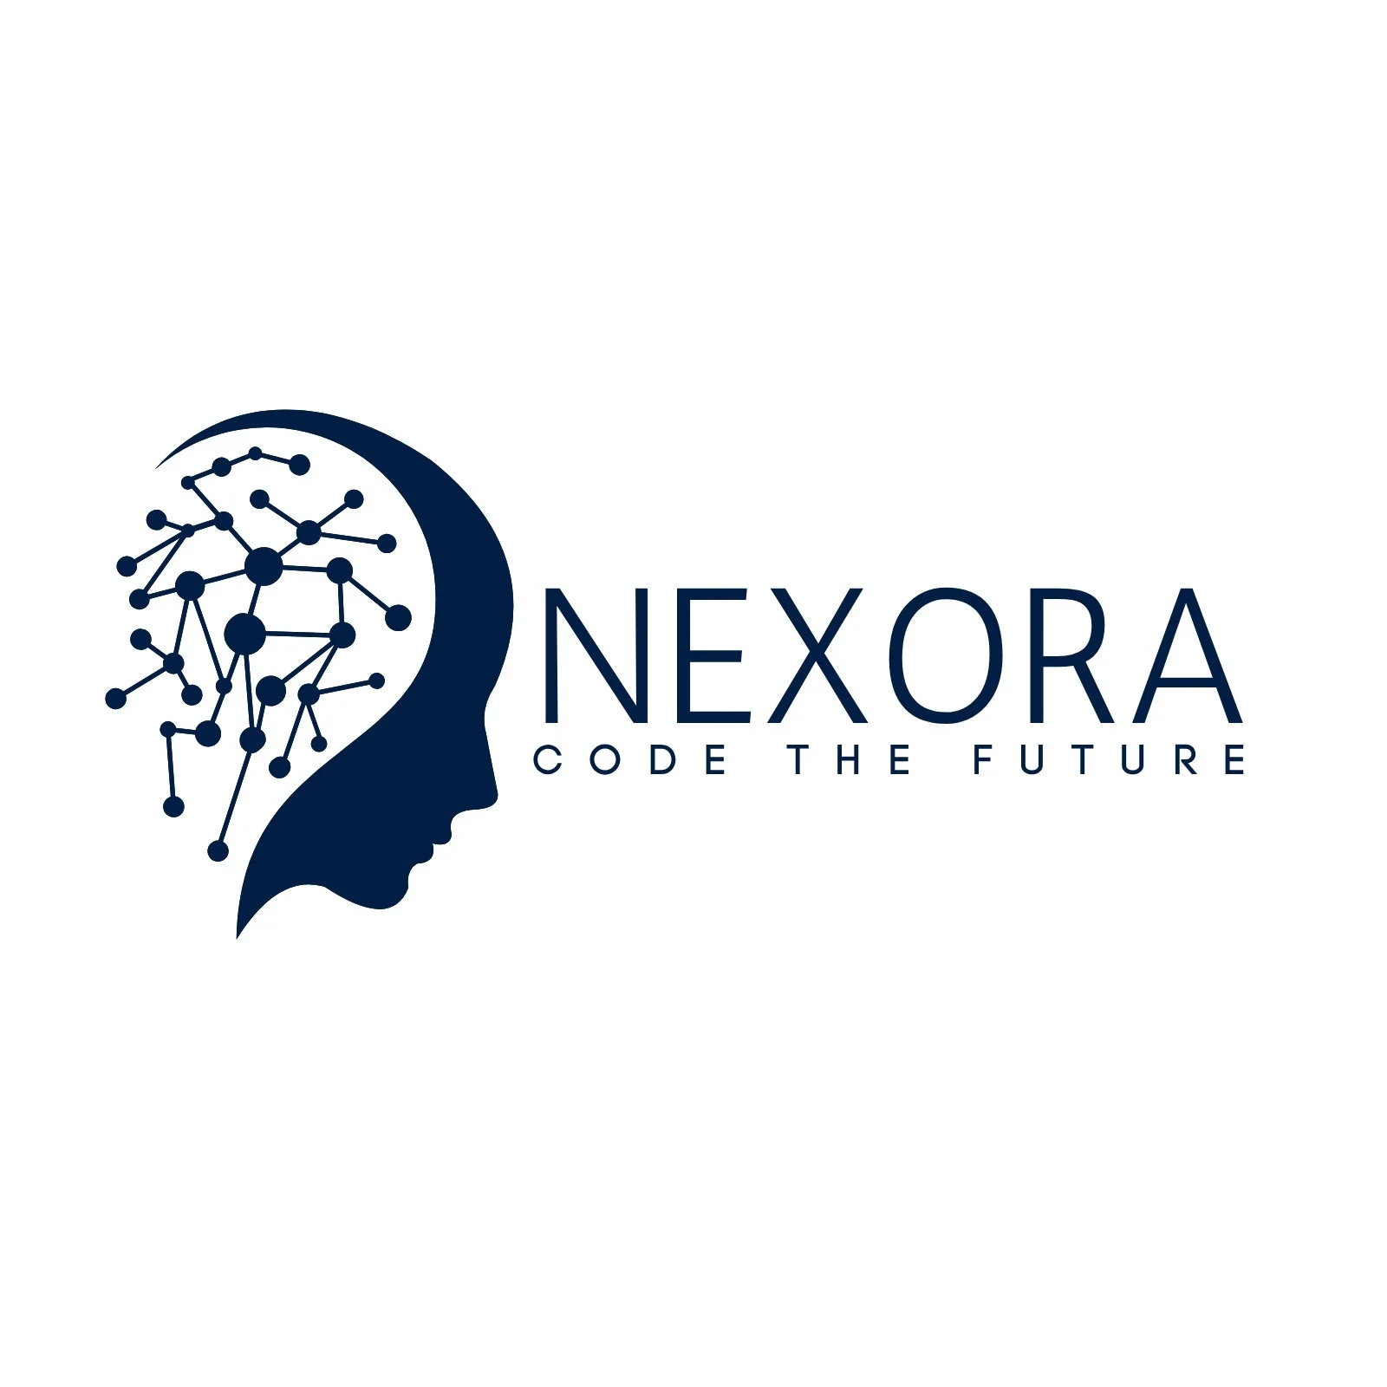

.

2. Prompt:
"Explain blockchain to a 5-year-old."
- Type: Instructional
- Reasoning:
This is a teaching or explanatory prompt. It requires simplifying a complex topic (blockchain) for a specific audience (a 5-year-old), which means it's focused on instruction, explanation, and communication in an age-appropriate way.

3. Prompt:
"You are a UX designer. Suggest improvements to this app layout."
- Type: Conversational / Instructional
- Reasoning:
This is a role-based prompt that initiates a simulated conversation or scenario where the assistant adopts a persona (a UX designer). The user is requesting professional advice or feedback, which can be both instructional (in terms of suggesting improvements) and conversational (because it simulates a dialogue with an expert).
  - If the user expects back-and-forth collaboration, it's more Conversational.
  - If it's a one-off request for suggestions, it's more Instructional.

TASK 2:[Refinement Practice
Given vague prompts, refine them to be more effective.]

2.
- Original: "Design a logo."
- Refined: "Design a minimalist logo for a vegan bakery named 'Green Crumbs', using earthy tones and a plant-based symbol."

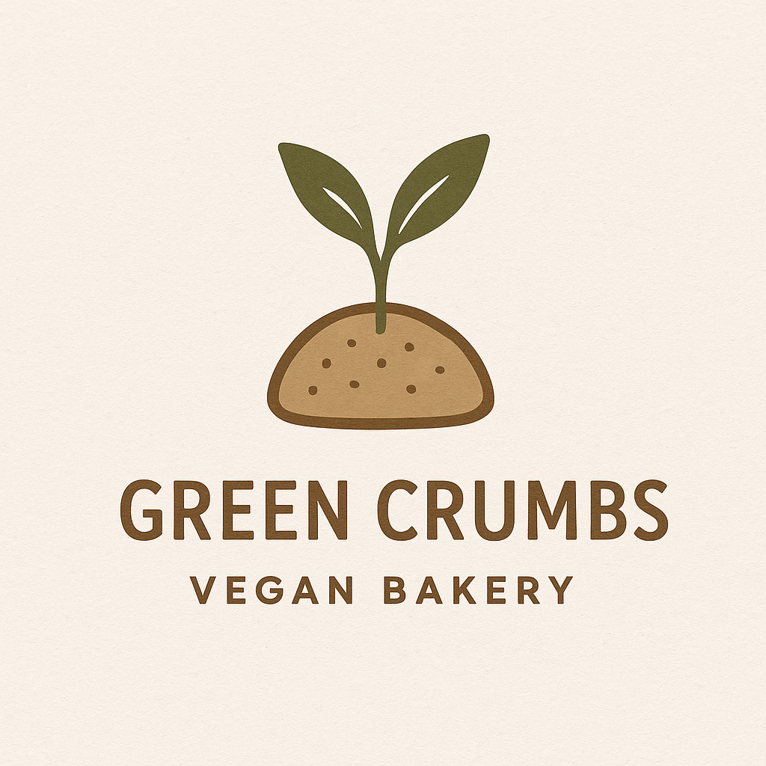

TASK 3:[Design 5 original prompts for different domains]

1. Text-Based Prompt (for ChatGPT)
Domain: Creative Writing / Storytelling
Prompt:
"Write a first-person short story (400–600 words) from the perspective of a time traveler stuck in the year 1923. The story should explore their struggle to blend in while trying to fix a broken device. Add emotional depth, a twist ending, and historically accurate references."

2. Image-Based Prompt (for DALL·E or similar)
Domain: Graphic Design / Branding
Prompt:
"Generate a high-resolution logo for a futuristic eco-resort called 'Solar Nest'. The logo should feature a modern solar panel integrated into a bird’s nest design, using soft gradients in blues and greens. Style: sleek, minimalist, and nature-inspired."

3. Video-Based Prompt (for SORA or similar)
Domain: Cinematic / Environmental
Prompt:
"Create a 20-second cinematic video showing a lush rainforest waking up at dawn. Include slow-moving fog over tree canopies, birds taking flight, beams of sunlight breaking through the mist, and soft ambient nature sounds. Camera movement: smooth aerial pans and slow zoom-ins."

4. Coding or Logic-Based Prompt
Domain: Algorithms / Software Development
Prompt:
"Write a Python function that takes a list of strings and returns a new list containing only the strings that are palindromes. Optimize the function for readability and performance, and include at least one test case."

5. Education or Training Prompt
Domain: Instructional Design / Microlearning
Prompt:
"Create a 3-slide microlearning module to teach new retail employees how to handle customer complaints effectively. Use simple language, include one real-world example per slide, and end with a quick knowledge check question."

